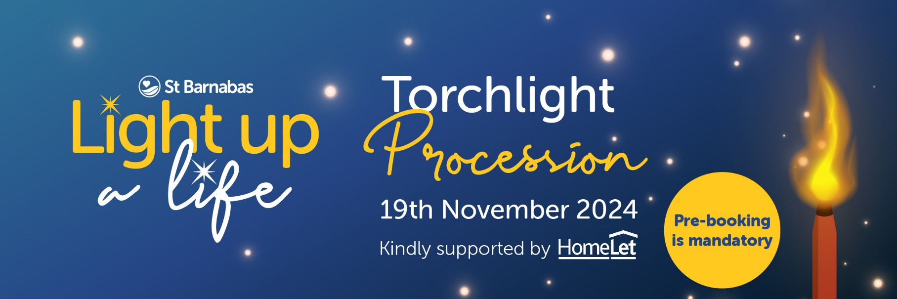

**St Barnabas Hospice Torchlight Procession 2025 - FAQs**

**What roads are closed and when?**

Road Closures & No Waiting/No Loading Orders are in place on:

* Nettleham Road – Longdales Road
* A15 – Pottergate Junction
* Lee Road – Wragby Road to Nettleham Road
* Nettleham Road – Lee Road to Priory Gate
* Priory Gate – Nettleham Road to Wragby Road
* Church Lane – Nettleham Road to Newport
* Eastgate – Nettleham Road to Greetwell Gate
* Newport – Bailgate to Rasen Lane
* Bailgate
* Castle Hill – Exchequer Gate
* Minster Yard

***Period of Restrictions: 18/11/2025 (6:00 PM to 9:00 PM)***  
Restrictions will be implemented as needed in each location during this period, with signage detailing accurate dates and times displayed on-site in advance.

**Where can I park to avoid the road closures?**

We sincerely thank Lincoln Christ’s Hospital School and Bishop Grosseteste University for kindly providing parking facilities for the event.

Lincoln Christ’s Hospital School’s car park, located at Wragby Road, Lincoln, LN2 4PN, will be open from 4:00 PM to 9:30 PM and has a capacity of 450 vehicles. Please ensure all vehicles are removed by 9:30 PM, as any remaining cars will be locked in until the following day.

Both facilities operate on a first-come, first-served basis. To help reduce congestion, we encourage attendees of the Torchlight Procession to carpool whenever possible.

**Are there any parking suspensions in place?**

Yes, parking suspensions will be enforced on the following roads during the period of restrictions:

* Corner of Lee Road onto Nettleham Road
* Nettleham Road
* Church Lane
* Bailgate
* Exchequer Gate
* Minster Yard
* Eastgate

**What is the event schedule?**

* ***6:15 PM - 7:00 PM:*** Gates to Clayton Sports Ground open for members of the public to arrive, collect their torches and lanterns (if pre-purchased), and be directed into the procession lanes.
* ***7:30 PM:*** The procession begins, leaving Lee Road to travel past the St Barnabas Inpatient Unit, through Bailgate, to the Cathedral.
* ***9:00 PM:*** The service concludes, and supporters are invited to tie messages of love around the Tree of Life.

This year, both the Lincoln Cathedral and Church of St Mary Magdalene will be open following the Torchlight Procession to offer space for reflection and members of our Wellbeing Team will be present to offer support if required.

**How much does it cost to attend the Torchlight Procession?**

This year, to help cover event costs, we will be charging for tickets. Torches and lanterns must be pre-booked during the ticket purchase for collection on the night. Once registered, you will receive a confirmation email with details of your booking and purchases.

Ticket Prices:

* Adult entry with torch (age 18+): £15
* Adult entry with lantern (age 16+): £15
* Adult entry only (age 16+): £8
* Child entry with lantern (age 3-15): £10
* Child entry only (age 0-15): £2

**What is the age requirement to walk in the procession?**

All ages are welcome at the Torchlight Procession. Children under 14 must be accompanied by someone over 18. Only those aged 18 and above may walk with a torch.

**Can I attend if I have mobility issues?**

Yes, the Torchlight Procession aims to be inclusive for all attendees. When registering, there is an option to indicate any mobility issues so we can better accommodate your needs. Alternatively, please feel free to contact us directly to discuss how we can best support you during the event.

**How long is the route?**

The length of the procession is approximately 1.6 miles, which will take about 32 minutes.

**What do I need to bring with me when attending the Torchlight Procession?**

1. ***Tickets:*** Please have your tickets ready, either printed or accessible on your phone, so they can be easily scanned by our team.
2. ***Suitable clothing and footwear:*** Be mindful of the weather and ground conditions and wear suitable clothing and footwear for the event.
3. ***Tree tag:*** If you have dedicated a light and want to add your message of love to the Tree of Life after the service at Lincoln Cathedral concludes, please bring your tree tag. Additional tags will be available for a small donation at both Clayton's Sports Ground and Lincoln Cathedral.

**What should I do if I lose sight of my child or someone in my care?**

If you become separated from your child or someone in your care, please contact a member of the team wearing a yellow or orange high-visibility vest. At Clayton’s Sports Ground, you can report a missing person at the sound van located towards the rear of the field, behind the procession lanes. At Lincoln Cathedral, please report to the St Barnabas Hospice Van located by the Visitor Information Centre, where our team will be able to assist you.

**Can I bring my dog?**

Unfortunately, dogs are not permitted at Clayton’s Sports Ground or along the procession route. Due to the nature of the event, including many people carrying wax torches with open flames, we strongly advise against bringing dogs to ensure their safety. Anyone who brings a dog will be asked to leave, and no refunds will be issued.

**What if there are adverse weather conditions?**

We will closely monitor the weather and make the best decision for the event and the safety of attendees. Ideally, we plan to proceed as scheduled, but any necessary announcements will be communicated via email to those who registered and through our various communication channels.

**I haven’t dedicated a light yet, but I’d like to. How can I do this?**

Each year, we invite the community to dedicate a light and allow someone’s memory to shine brightly on our Tree of Life outside Lincoln Cathedral. You can remember anyone, not just those cared for by the Hospice. As a thank you, we will send a personalized card, a memory tag for the Tree of Life, and a decoration for you to display in your own home. You can dedicate a light for the Light up a Life campaign by visiting: [stbarnabashospice.co.uk/LUAL](https://stbarnabashospice.co.uk/LUAL)

**What happens if the event is postponed or cancelled?**

In the event that the Torchlight Procession is postponed or cancelled, the following terms apply:

1. ***Notification:*** Attendees will be informed of any changes via email and through our official communication channels as soon as possible.
2. ***Refund Eligibility:*** Refunds will be considered for those who have purchased tickets. Further details will be provided through our official channels.
3. ***Force Majeure:*** We shall not be liable for any failure to perform our obligations under these terms if such failure results from events beyond our reasonable control, including but not limited to natural disasters, acts of government, or other unforeseen circumstances.

If you have any further questions, please contact us on 01522 540300 or email [fundraising@stbarnabashospice.co.uk](mailto:fundraising@stbarnabashospice.co.uk)